<https://www.euvsvirus.org/results/>

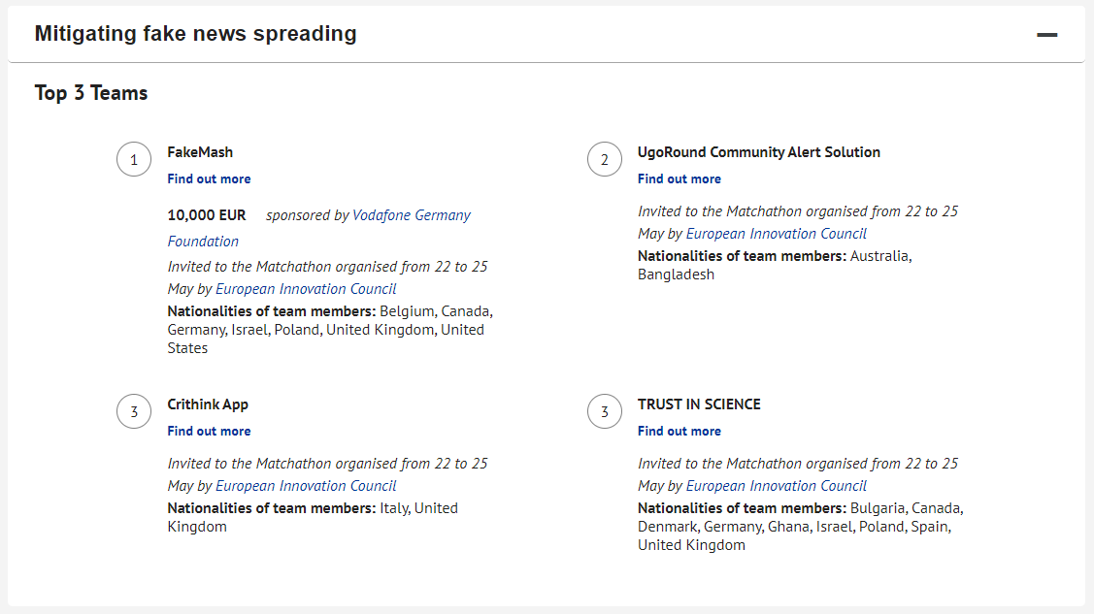

Community feedback (condensed for video):

**Great idea, love it.**

**I love your approach to this problem!**

**Congratulations, remarkable work!**

**I really hope you guys can get this up and running, I’d sign up for sure!**

**Congratulations, keep it up!**

**Oh man. I love this so much! This is greatly needed and crucial. Great work!**

Original community responses:

Oh man. I love this so much! Can I come work for you? lol, really though, this is greatly needed and crucial. Great work!

Congratulations, remarkable work! Don't be shy to create a bunch of issues on GitHub so open-source developers if there is anything they can contribute…

Great idea, love it, hope you get what you need.

I love your approach to this problem! Have you tried reaching out to Wikipedia? They have a similar approach to their content, and I believe they started a social media site last year with the same goal in mind. They might have some good insight for building a community of volunteers.

Hey Thomas, I really hope you guys can get this up and running, I’d sign up for sure!